

**GAYAZA JUNIOR SCHOOL**

**LITERACY II FOR P.1 TERM I 2020**

**Name:________________________stream_______**

1. What is a school?

___________________________________

1. Why do people go to school?

____________________________________

1. Who heads a school?

____________________________________

1. Give any two groups of people who work at school

__________________ _______________

1. 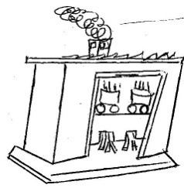Name these buildings found at school.

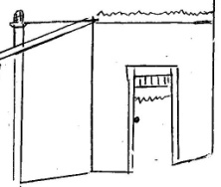

____________________________ ___________________________

1. Where do school children go for treatment at school?_____________________________
2. Why does a school need dormitories?

_____________________________________

1. Fill in the missing letters.

te___cher st__nes nu__se

matr__n bu__sar penc__l

1. What is the name of your headteacher?

______________________________________

10. Why is a teacher needed in a school?

______________________________________

11. Match people to their work places.

Cook classroom

Matron kitchen

Secretary office

Teacher dormitory

12. Name these classroom objects.

|  |  |  |  |
| --- | --- | --- | --- |
| Picture 031 | Picture 135 | Picture 155 | Picture 031 |
|  |  |  |  |

13. List down any three things found in the school

compound.

_________________ ________________

_________________

14. What is the use of brooms in our school?

_____________________________________

15. Where do we throw rubbish after picking it?

______________________________________

16. Where are school books kept?

______________________________________

17. Name these school symbols.

|  |  |  |
| --- | --- | --- |
| https://lh3.googleusercontent.com/jE8gFWWf3-N21YLVOpq8d4EJTfoth2el7FSrNH59aeSWrli0KDv4-Y4vIuUXufFRVFE1=s162 | https://lh3.googleusercontent.com/jE8gFWWf3-N21YLVOpq8d4EJTfoth2el7FSrNH59aeSWrli0KDv4-Y4vIuUXufFRVFE1=s162 | https://lh3.googleusercontent.com/jE8gFWWf3-N21YLVOpq8d4EJTfoth2el7FSrNH59aeSWrli0KDv4-Y4vIuUXufFRVFE1=s162 |
|  |  |  |

18. What is the colour of your school uniform?

______________________________________

19. What is your school motto?

______________________________________

20. Why do children wear school uniforms?

______________________________________

21. Write the three letters found on the school badge.

___________ ___________ ___________

22. Which school symbol directs people to school?

______________________________________

23. Name these activities done at school.

|  |  |  |
| --- | --- | --- |
|  | C:\Documents and Settings\Lydia\Local Settings\Temporary Internet Files\Content.Word\Picture 146.jpg | C:\Documents and Settings\Lydia\Local Settings\Temporary Internet Files\Content.Word\Picture 139.jpg |
|  |  |  |

24. Name any two activities children do on sports day?

_______________________________

_______________________________

25. What is a home?

______________________________________

26. Who heads a family?

______________________________________

27. Why do we need a granary at home?

______________________________________

28. Where do people go for short or long calls at home?

______________________________________

29. Name these people found at home?

|  |  |  |
| --- | --- | --- |
| Picture 060 |  |  |
|  |  |  |

END



**GJS LITERACY I P.1**

1. 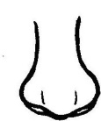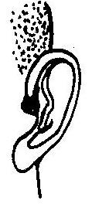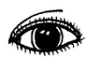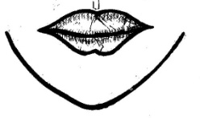Name these parts of the head.

2. Why do people need eyes?

______________________________________

3. Which body part do people use for smelling.

______________________________________

4. Write these words correctly.

i) thmuo ______________________

ii) sare ______________________

iii) cken ______________________

5. Name these things we use to clean our body?

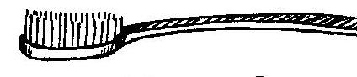 ____________________

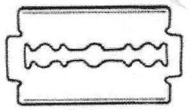

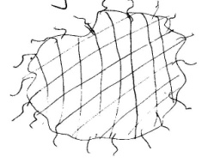 _____________________

_____________________

6. Why do people keep hens at home?

_____________________________________

7. How many legs has a cow?

___________________________________

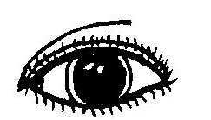8. Match correctly.

Smelling



Tasting

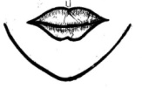

Seeing

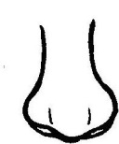

Hearing

9. Name the food we get from cows?

_______________________________________

1. Write down any two animals which eat grass.
2. __________________________
3. _________________________

11. Fill in the missing letters.

i) w__t__r iv) sp__n__e

ii) bu__k__t

iii) s__ __p

12. Which animal eats rats at home?

___________________________________

13. Name these foods eaten at home.

Picture 144Picture 144Picture 144Picture 144Picture 144 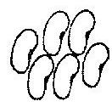 ________________ _________

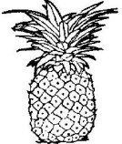 _______________ 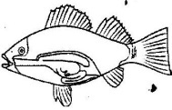 _________

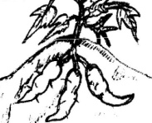 ____________

14. Why do we brush our teeth?

______________________________________

15. Underline the common diseases.

Polio, Mumps, Tetanus, Whooping cough, Measles,

Malaria.

16. Name these activities we do to keep our bodies

clean.

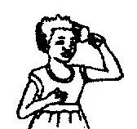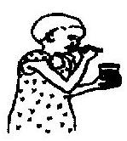

_______________ _____________

17. We__________our hands after visiting the toilets.

18. Which disease is spread by a mosquito.

__________________________

(Typhoid, Melarai, Malaria, Measles)

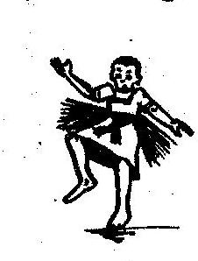19. Name these body exercises.

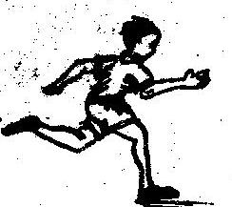

________________ __ _____________

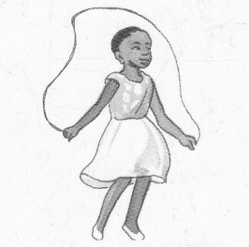

_______________

20. Name the parts of the arm.

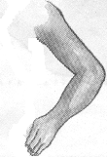

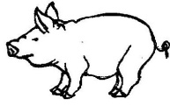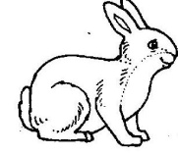21. Name the animals.

______________ _____________

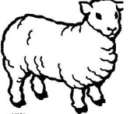

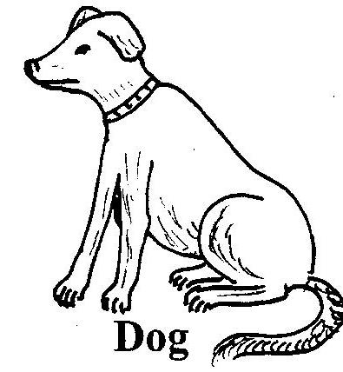

_____________ ____________



**GJS MATHEMATICS P.1**

1. Count and write

Picture 131Picture 131Picture 131Picture 131Picture 131Picture 131a) ______________________

b) _____________________

c) ______________________

d) ______________________

2. Name these groups.

a) A group of balls

b) ______________________________

c) ______________________________

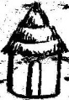

d) _________________________

3. Match the same groups.







4a) What is a set?

______________________________________

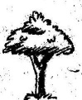b) **Match correctly.**

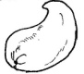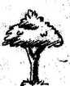c) **Match the same.**

Picture 144Picture 132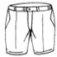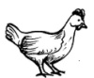i)

5. **Make new sets.**

Picture 200Picture 200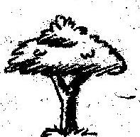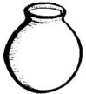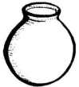Picture 200Picture 200

Picture 200



6. Draw the following sets.

a) A set of stars.

b) A set of flowers.

c) A set of pencils.

(d) A set of books

Picture 144Picture 1447. Identify numbers on the cards.

Picture 144Picture 144a)

___________

Picture 144Picture 144Picture 144

Picture 144Picture 144Picture 144

b) _____________

8. **Comparing sets.**

A B

Picture 131Picture 131Picture 131Picture 131Picture 131Picture 131a)

Picture 131

Set A has __________members.

Set B has __________ members.

b) M N

Set M has _____members.

Set N has _____members

9. **Use less or more**

Picture 144Picture 144Picture 144Picture 144Picture 144Picture 144a) A B

Set A has _________members than set B.

Set B has _________members than set A.

10a) What is an empty set?

______________________________________

b) Draw an empty set.

1. **Join the sets.**

Picture 144Picture 144Picture 144Picture 144

Picture 144 and make

Picture 131

Picture 131b. and make

4 + ___ = ____

12. Separating sets.

Picture 144Picture 144a) _ =

Picture 131Picture 131Picture 131

b) _ =

1. **Fill in the missing ordinal numbers.**
2. 1st ____, 3rd _____, 5th
3. 6th ____, 8th , 9th , ____

14. Ordering sets.

a) -2 -1 -3

Draw these sets again in order.

Picture 144Picture 144Picture 144Picture 144Picture 144Picture 144Picture 144Picture 144Picture 144Picture 144b)

-4 -3 -1 -2

**The sets have been drawn again, order using ordinal numbers.**

15**. Fill in the missing numbers.**

a) 1, 2, ___, 4, 5, ___

b) 7, 8, ___, 10, ___

c) 6, ___,4 , ___, 2, 1

16. **Write number words.**

8 __________________ 4 ______________

9 __________________ 3 ______________

7 __________________ 2 ______________

6 __________________ 1 ______________

5 __________________ 0 ______________

17. **Add these objects.**

a) + = _______

b) + = _______

18. **Add correctly.**

a) 4 + 3 = ____

b) 7 + 1 = ____

c) 2 + 0 = ____

d) 5 + 1 + 2 = ____

Add:

1. 5 b) 6 c) 4

+3 + 2 1

+3

Add:

1. Four plus three equals _____________
2. Six plus one equals _____________
3. What is five plus three?
4. Anna has 4 books

Mary has +3 books

They both have books

19. Use taller, longer and shorter.

A

imagesimages B

Bottle A is ________________than bottle B

Bottle B is ________________than bottle A

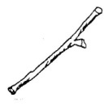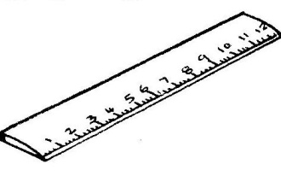 ruler

stick

1. The ruler is ________________than the stick
2. The stick is ________________than the ruler.

20. Use “heavier” or lighter”

a) stone A stone B

1. Stone A is ______________than stone B.
2. Stone B is ______________than stone A.

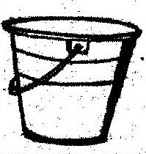

 bucket

cup

1. The bucket is _____________than the cup.
2. The cup is _______________than the bucket.

**Take away.**

21. 9 -4 =

b) 5 - 5 =

c) 8

-3

d. Seven cats minus three cats

e. Eight dogs take away five dogs gives.

f. What is 7 minus 2?

Find the missing number.

1. ______ + 5 = 8
2. 6 + _____ = 10

**END**



**GJS ENGLISH P.1**

**THEME** : **OUR SCHOOL**

1. My name is ____________________________

My school is ___________________________

My class is ____________________________

How old are you?

I am _____ years old.

Are you a girl ?

____________________________________

What is the name of your class teacher?

__________________________

1. **Fill in the missing letters of the alphabet.**
2. A B ___ D E F
3. G___ I J K L
4. M N O___ Q
5. **Write these words in small letters.**

BADGE __________________

SCHOOL __________________

FLAG _____________________

**Write these letters in ABC order.**

1. a f c b ______________
2. k i l m ________________

**Write the letter which comes before and after.**

1. ____ b ____ (b) ____ g ____
2. **Write ‘a’ or ‘an’ to complete the sentences correctly**.

a) Show me ____ orange.

b) Bring me ___ hoe and ___ axe.

c) ______ aeroplane is flying over the hills

5**. Read and draw people found at school.**

|  |  |  |  |
| --- | --- | --- | --- |
| Teacher | Pupil | Cook | Cleaner |
|  |  |  |  |

6. **Fill in He or She**

i) Ritah is a girl

_____ is in Primary One.

ii) Peter is a boy

_____ is in Primary Two

1. Our teacher of English is a woman.

______is called Mrs. Mwebaza.

1. Our headteacher is a man

______ is called Mr. Musisi.

7. Name these objects.

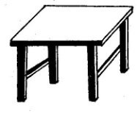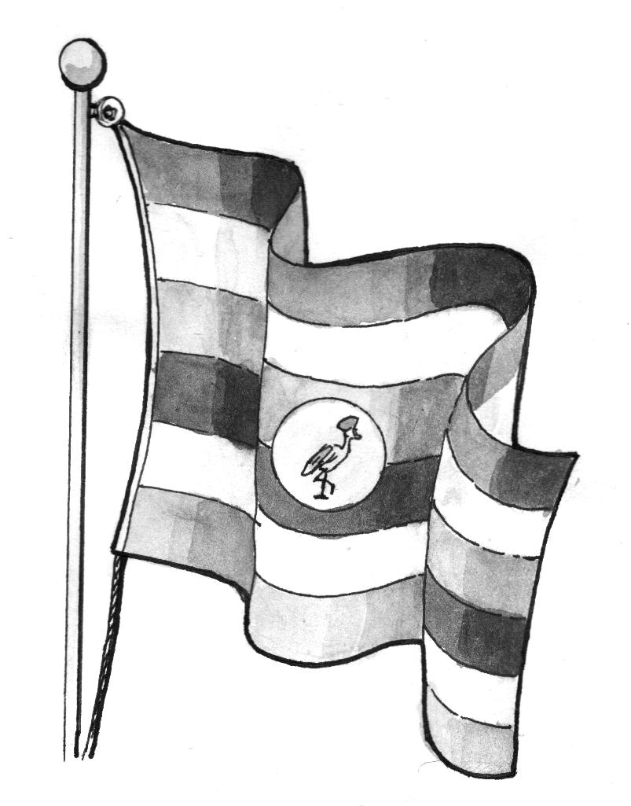

**_________________ ____________**

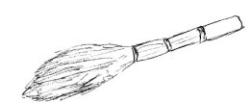

**_______________ ____________**

8. Fill in the missing letters.

w___nd___w p___nc___l d___st___r

r___ler cha___kbo__rd b___x

9. Activities done at school

**Read and draw the picture.**

Namuli is sweeping the compound.

John is reading a book.

Ritah is running to school.

Juma is dancing.

10. Complete the following sentences.

ballballballball One ball many _________

Picture 216Picture 216Picture 216Picture 216 One pencil many _________

One ______ many _________

**11. Use the given words in their plural form.**

a) Nalule has ten ______________(book)

b) These are two _____________(table)

c) There are twenty_________in the classroom. (girl)

**12. Circle the oddman out**.

a) chair tree, pencil, book.

b) Jane, Sarah, Peter, Ruth.

c) Chair, bag, knife, table.

d) goat, bench, duster, ruler.

**Add -ing to the verb.**

1. clean = cleaning
2. wash = _______________
3. drink = _______________
4. swim = _______________
5. skip = ________________
6. clap = ________________
7. drive = ________________
8. come = ________________
9. weave = ________________
10. **Read and shade these colours**.

blue yellow

green red

black purple

**OUR HOME**

1. **Fill in the gaps with ‘’is’’ or ‘’are’’**
2. There ____ many oranges in the basket.
3. That _____ a policeman.
4. These _____ yellow bananas.
5. _______ Peter a good boy?
6. **Write these words correctly.**

therfa _ __________ tersis _ _________

thermo _ __________ cleun _ _________

ons _ __________ manwo _ ________

sincou _ ________ mothergrand _ _________

1. **Write these sentences correctly.**
2. food cooking Mother is some

_________________________________

1. pounding groundnuts. The grandmother is

_________________________________

1. milking the cow Father is

_______________________**__________**

1. **Draw and name four animals found at home.**

|  |  |  |  |
| --- | --- | --- | --- |
|  |  |  |  |
|  |  |  |  |

1. **Use the words in brackets correctly.**

i) The train is ___________on the railway line.

(move).

ii) The children are___________now. (dance)

iii) Mr. Kato is ___________in the garden.(dig)

iv) Alice is ______________ (grind)

v) Mrs. Kato is ___________ matooke. (peel)

**20. Underline the doing word (verb)**

1. I am learning English now.

2. The children are eating maize.

3. Mother is cooking maize.

4. The baby is sleeping.

5. The teacher is writing on the chalkboard.

**21. Read and answer correctly.**

key2 Is this a key?

Yes, it is

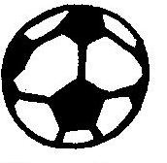 Is this a stone?

No, it is not.

Is this a hat?

____________________________

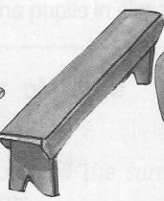

Is this a bench?

_____________________________

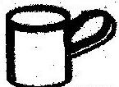

Is this a pot?

______________________________



Is this a tree?

_______________________________

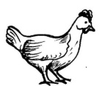 What are these?

_______________________________



How many eggs can you see?

_______________________________

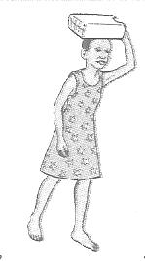basket22. Make sentences about what is happening.

a)

_______________________________



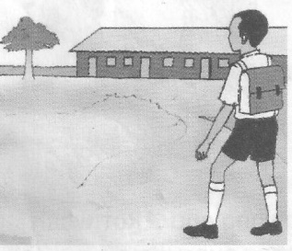b)

_________________________

Picture 154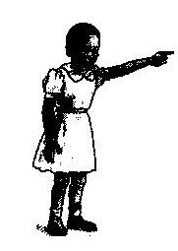

c)

_________________________________

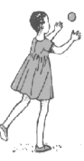

d) _______________________________

**Read the story and answer correctly.**

23. The Grandmother.

Nakato and Babirye have a grandmother. Her name is Mrs. Lubuto. She lives at Naalya town. She has a big farm. She grows maize, cassava, pineapples and sugarcane. She has goats, cows and sheep. She is a hardworking woman.

1. What is the grandmother’s name?

The grandmother’s name is _______________

1. Where does she live?

She lives at ___________________________

1. What does she grow?

She grows maize, ___________and _________

1. Write three animals she has

___________, ___________, __________

1. Draw Nakato and Babirye with their grandmother.

END